EXPERIMENT NO. 16

Containerizing and Serving a Static Website Using Docker

Aim
To create a simple static website, containerize it using Docker, and serve it through an Nginx web server.

Software Requirements
- Windows 10/11 (or Linux/macOS)
- Docker Desktop
- Visual Studio Code (or any code editor)
- Web Browser

Theory
Docker is a containerization platform that packages an application along with its dependencies into a container. Nginx is a lightweight web server commonly used to host static websites. By using Docker and Nginx, a static website can be deployed consistently across different systems without additional configuration.

Procedure
Step 1: Create the Project Folder
Create a new folder named static-website. Inside the folder, create a file named index.html.
Step 2: Create the HTML File
Create index.html with the following content.
<!DOCTYPE html>
<html>
<head>
<title>My Docker Website</title>
</head>
<body>
<h1>Welcome to My Static Website</h1>
<p>This website is served using Docker and Nginx.</p>
</body>
</html>

Step 3: Create the Dockerfile
Create a file named Dockerfile inside the project folder.
FROM nginx:alpine
COPY index.html /usr/share/nginx/html/index.html
EXPOSE 80

Step 4: Build the Docker Image
Open Terminal or Command Prompt in the project folder. Build the Docker image.
docker build -t static-website .

Wait until the image is created successfully.
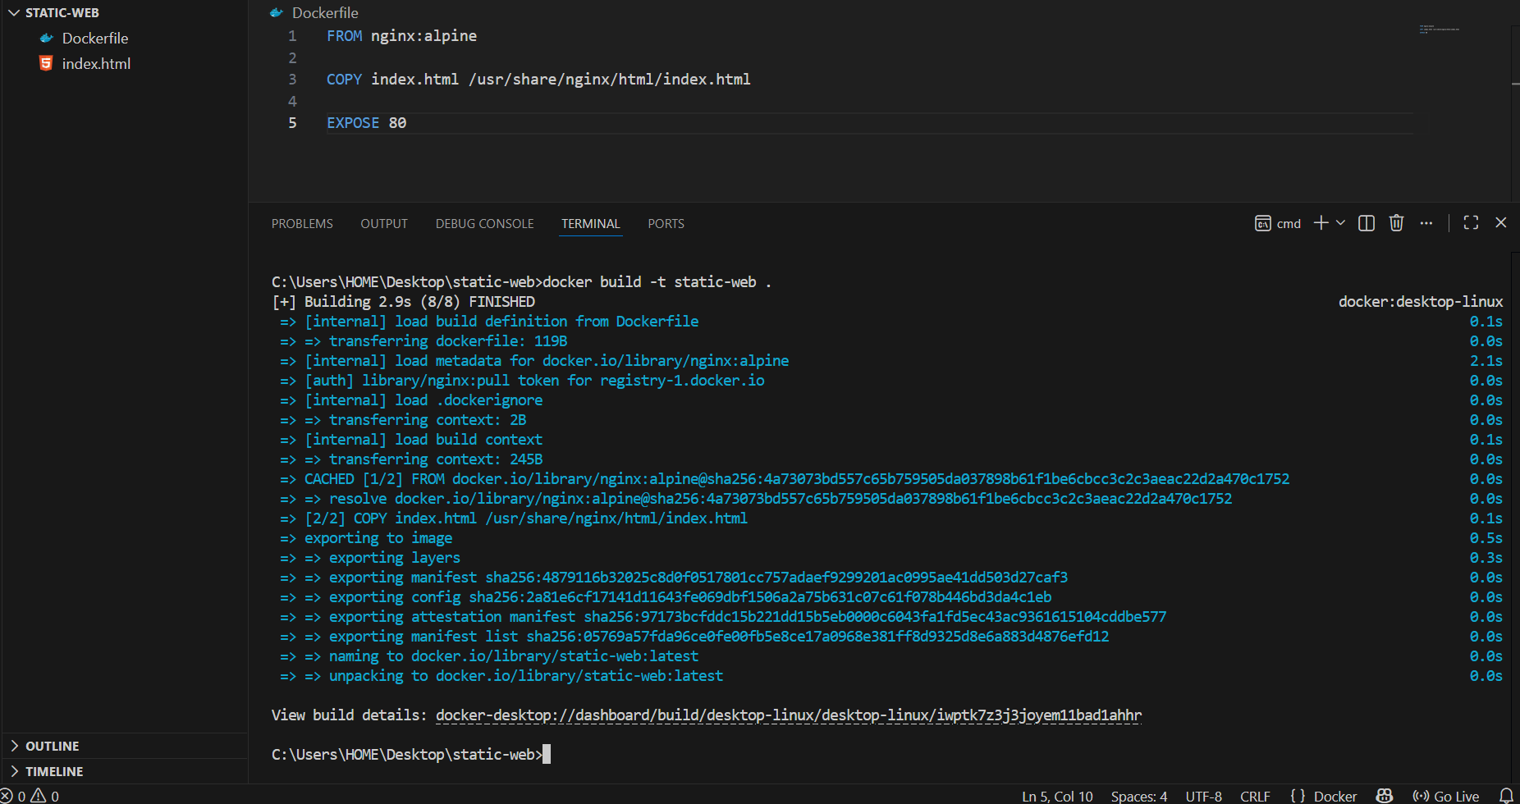
Step 5: Run the Docker Container
Run the container.
docker run -d -p 8080:80 --name static-container static-website

Verify that the container is running.
docker ps
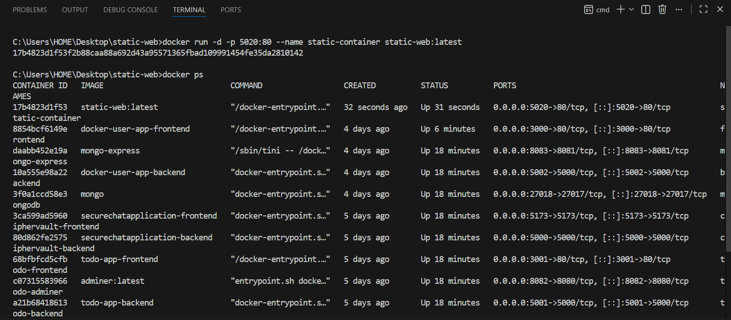

Step 6: Access the Website
- Open any web browser.
- Enter the following URL: http://localhost:8080
- The static website will be displayed.

Screenshots
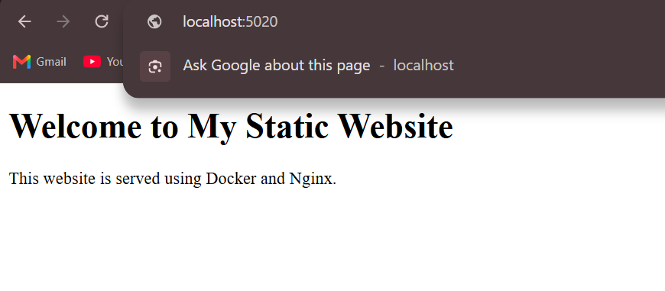

Observation
- The HTML file was created successfully.
- The Docker image was built successfully.
- The container started without errors.
- The website was accessible through the browser using http://localhost:8080.

Result
The static website was successfully containerized using Docker and served through the Nginx web server. The website was accessed successfully in a web browser using the Docker container.

